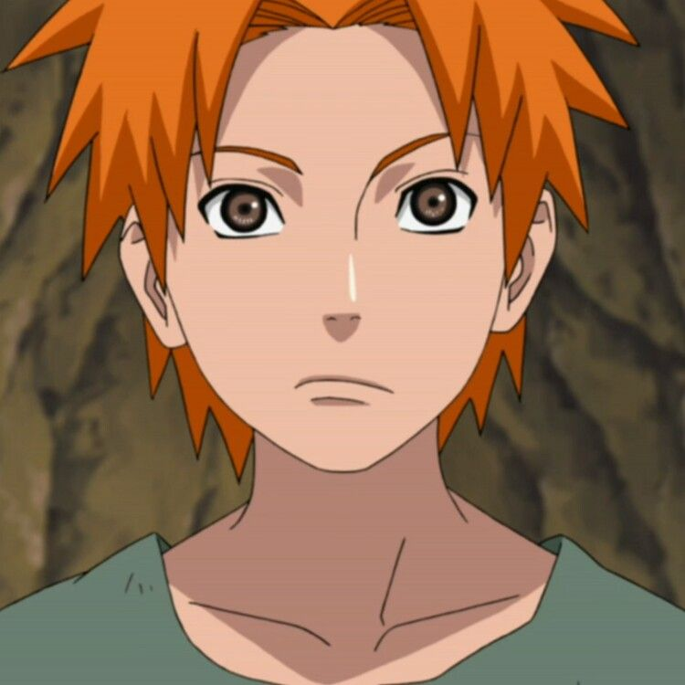

**Fuma Clan**

The Fuma *(ふうま一族, Fūma Ichizoku)* are one of the three clans residing in Watashitachi wa, Ataryoshi. They are well known for their ninja tool crafting ability, as well as their ability to utilize a variety of shinobi tactics. They are known to be the first clan to truly adopt the shinobi way.

History

**Preface**

The Fuma Clans origin originates back into the Clan Period, where they had become traveling merchants. They would travel from place to place, trading their wares for information rather than money or items. From each place they visited, they would take time to learn the way of the people, the land, and their way of living. From each place they would take, until they created something of their own. This is where the clan is known for its many professions, as each member had extensive knowledge on at least one profession. Cooking, Farming, Smithing, Tailoring, Acting, and even the art of being a Shinobi were all easily mastered by the clan. They were regarded as the only clan that could sustain off of their own ability and knowledge alone. Fuma were the first to partake in the lifestyle of shinobi, taking their abilities and putting them on sale for currency. This clan effectively turned knowledge into power, raising from the muck and mire to something prominent and well respected by others.

**Current**

Currently the Fuma have joined with the Yotsuki and Inuzuka in Ataryoshi as their primary smiths and frontline shinobi. Their only interest currently is to grow Ataryoshi much like the others who reside their and to gather as much knowledge at they can to pass down to the next generation of Fuma. Knowing that this method is what created their clan, they choose to not neglected it and keep the cycle of strength ever flowing in their favor.

Description

The Fuma are ironically known from their orange hair that varies from shades. Their eyes are various shades of brown but can sometimes be seen to be blue or green, and rarely a shade of orange similar to their hair.

Fuma are extremely prideful in their work and abilities, often looking to improve on them. Fuma often have a perfectionist nature to themselves, wanting to perfect both themselves any craft they choose to learn.

Player Guide

*Fuma characters are known to have diverse personalities, none following an exact pattern. They are all naturally gifted at the creation of weapons, at least to the point of making their own Trick Weapon. Not all Fuma have Trick Weapon although most have the knowledge to create them. The Fuma clan are naturally good at trickery and subterfuge as well as bartering, giving them a natural advantage when it comes to buying and selling.*

*-*Fuma have different shades of orange hair typically, but can be shades of off-yellow.

-Fuma have access to their own specific store which allows them to buy Fuma Specific weapons.

- Fuma’s Trick Weapons even when stolen can rarely be mastered by someone who is not themselves a Fuma.

- Fuma often put a Fuma signature on their weapons instead of their own, this is due to people being unable to find out which Fuma exactly made the weapon for various warfare and clearance reasons.

-The Fuma do not use traditional black smithing methods and have their own secret style when it comes to weapon crafting.

-Fuma’s diet are quite diverse and they take and borrow from all other clans, houses, and cultures.

-The Fuma’s education is quite advanced, learning the basics of Math, English, Science, and Social Studies. They also take dialect, and history of most other clans.

-Like all other members of Ataryoshi they take a basic military school course.